Assignment 6

Understanding machine learning

The Basics
Before Wednesday in class: read this document and make note of any questions you might have.

Wednesday 10/15 and Friday 10/17: will be studio classes devoted to this assignment.

Monday 10/20: present your assignments

Friday 10/27: final version due in class.

Machine learning is the driving force behind modern AI. The basic idea is, rather than write a program to solve a problem, write a program that reads in enough data to be able to write a program to solve the problem. The program that solves the problem is called a model and the program that creates the model is called a learning algorithm.

In this assignment, we will seek to learn some of the basic theoretical building blocks behind machine learning. State-of-the-art machine learning algorithms are capable of complex actions and can maintain state over multiple interactions (i.e., they have “memory”), however, as with complexity theory we will focus on a simplified environment. Rather than restrict ourselves to languages, we focus instead on functions, where the goal is to learn a model h that maps from an input domain X to an output domain Y. Here, X could be a set of strings, but it is more typically thought of as a set of numbers or a vector space. This kind of learning is called inductive learning.

The basic empirical risk minimization problem is as follows: there is a training set of n (example, response) pairs, (x₁, y₁), (x₂, y₂), … (x_{n}, y_{n}) taken as samples from a probability distribution P(x,y) over input and output domains X and Y. In a real-world setting, this would be data collected from the environment where the model would operate, and serve as examples for how the model should respond. There is also a hypothesis space H, consisting of all models the learning algorithm may choose from (in the real world, this might be the set of all transformer neural nets with a certain number of layers each of a certain number of dimensions). Finally, there is a loss function L: Y, Y → R. The goal of the learning algorithm is to choose a model from the hypothesis space that minimizes the empirical risk:

arg min_{h∈H} ∑_{n} L(y_{n}, h(x_{n}))

This is essentially the root of all machine learning.

Q1: Draw a diagram of the concepts described above. The diagram should have an object representing each of the concepts shown in bold and it should show how they are related (imagine you were drawing an illustration for a text book).

Next, imagine the following idealized and simplified learning problem: You have data on the amount of potassium supplied to a study group of tomatoes (in parts per million in solution) and the average total sugar yielded (in grams).

K, PPM | Sugars, g
120 | 1.94
125 | 1.69
133 | 2.01
133 | 2.04
139 | 1.99
151 | 0.9
155 | 2.3
170 | 2.39
182 | 2.45
189 | 2.63
202 | 2.55
218 | 2.61
220 | 2.78
221 | 2.8
234 | 2.84
240 | 2.94
248 | 2.89
253 | 2.92
260 | 2.95
265 | 2.97
268 | 3.03

Suppose your hypothesis space consisted of the following models M1 through M5, and suppose your loss function L was the absolute difference function, i.e.,

L(y, y’) = |y - y’|

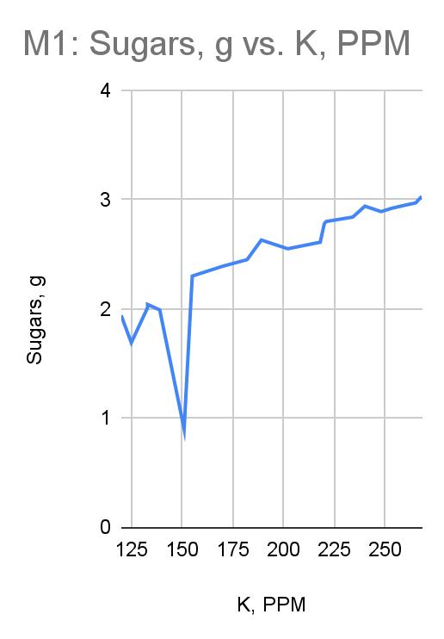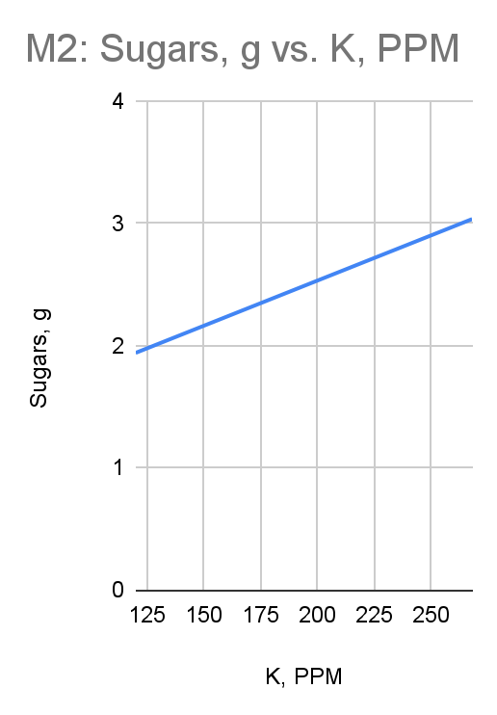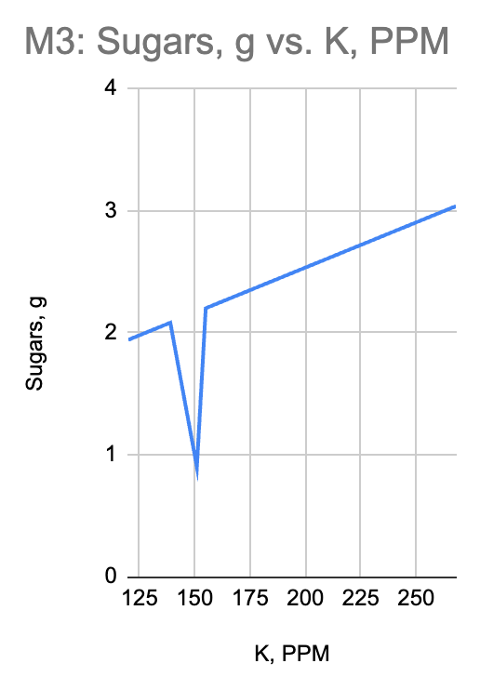
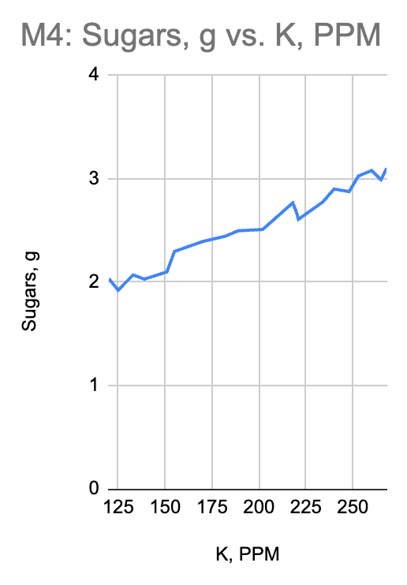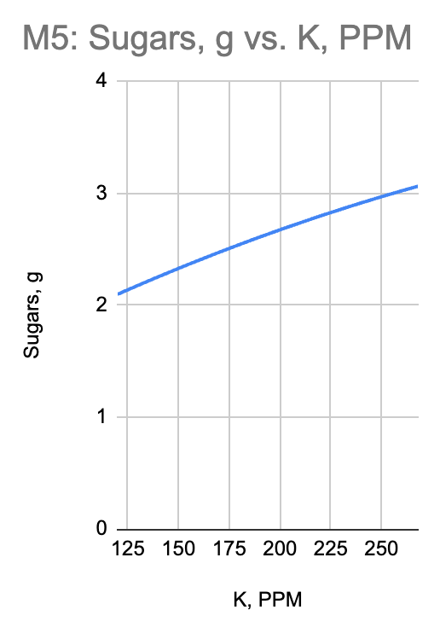

Q2: Which of these models is the ERM choice?

Q3: Which of these models would be the best choice, and why?

Q4: Instead of models M1–M5, you are allowed to choose one of the following hypothesis spaces. Which is best and why? Which is the worst and why?
- The set of all quadratic functions
- The set of all linear functions
- The set of all constant functions
- The set of all three-layer perceptrons with RELU activations and a 5-dimensional inner layer.
- The set of all sine and cosine functions.

Q5: Suppose, using your favorite hypothesis space, we replaced the loss function with simply the difference function:

L(y, y’) = y - y’

Give an example or two to show why that would be a bad idea.

